1. A photoelectric smoke detector shall be allowed to be installed within 6ft of the kitchen stove in an residential building. 文本

   描述已自动生成9.6.2.10.6
   1. 20ft 32.3.3.8.3\* (12)
2. How many stories tall is museum with two basement levels, a ground floor with a mezzanine level, and then floors 2-4. Cite the code reference. 文本

   描述已自动生成 文本

   描述已自动生成
3. A mezzanine is located above a room that is 200 ft by 90 ft by 30 ft high. The maximum allowable area of the mezzanine is . 文本

   描述已自动生成 8.6.10.2.1
4. In an existing, sprinklered school, 10 emergency drills are required. With approval, what is the minimum number that must be based on fire evacuation? 10-2=8 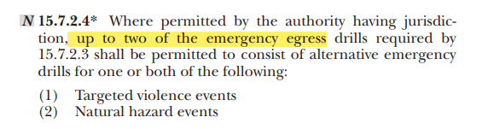 15.7.2.4
5. What marking is required on new glazing that passes a standard test and is rated at 2 hrs
6. In a new office building, who must be trained on using portable fire extinguishers? Designated employees of business occupancies图形用户界面, 文本

   中度可信度描述已自动生成38.7.3
7. Should the orientation of the floor plan used to provide emergency instructions for the guests in a new hotel be different from the opposite sides of the corridor
8. Can an existing, sprinklered out patient clinic have unenclosed vertical openings that do not meet the requirements of 8.6.8.1 文本

   描述已自动生成
9. Which is a point of safety. 报纸上的文字

   描述已自动生成
10. An existing, one-story store has an aggregate area of 2500ft. Is emergency lighting required? No 文本

    描述已自动生成图形用户界面

11. Should the orientation of the floor plan used to provide emergency instructions for guests in a new hotel be different for the opposite sides of the corridor
12. A wall in a new, sprinklered office building is 20 ft by 8 ft. How many 5 ft by 4 ft bulletin boards can be installed. 1 文本

    描述已自动生成
13. A door in a 1hr rated fire barrier between two different occupancies shall be rated for hr or higher 3/4 Table 8.3.3.2
14. Aside from the owner, who can classify the hazard of the contents in a warehouse? Registered design professional (RDP) 文本

    描述已自动生成
15. In an existing hospital, what is the minimum rating of the interior floor finish.
16. A new building is planning to have adults who are confined to beds being supervised during the day by staff. No one will be spending the night at the facility. Shall this facility be classified as a day care occupancy. 报纸上的一篇文章

17. In a new, sprinklered office building built in accordance with NFPA 101, a conference room with a capacity of 64 persons is incidental to an office space. Can the rules for the business occupancy be applied throughout. 文本

    描述已自动生成
18. Which of these places of outdoor furniture can be place within 2 ft of a new sprinklered apartment building? Indicate all that apply
    1. A metal chairs
    2. A plastic chair that has a peak heat release rate of 120 kw/m2
    3. A plastic chair that is made of class B plastic
    4. A plastic chair that was burned in a full-scale test with a measured heat release rate of 120 kw
    5. None can be placed within 2 ft of an apartment 文本

       描述已自动生成
19. The travel distance inside a new, sprinklered dorm room is 15ft. What is the maximum travel distance from the most remote location in the room to the nearest exit. 125ft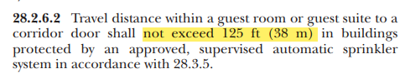28.2.6.2
20. In accordance with NFPA 101, should an area being used to store copier paper, pens, etc, for office use in existing ambulatory health care facility be protected in accordance with 8.7 文本

    描述已自动生成
21. Are smoke detectors required in a new prison in a sleeping room with three people assigned to it if the people can freely leave the smoke compartment 
22. An owner can install incidental trim with an area of up to on a wall that is 15ft wide by 2 ft deep by 8 ft high. 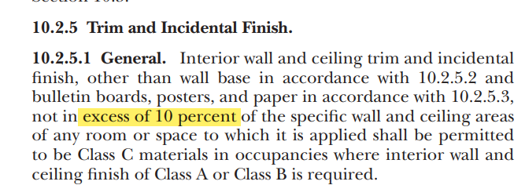
23. In an existing restaurant, what is the minimum dear width of an aisle access if the distance from the center seat to the aisle is 16ft 4 in
24. What is the maximum time allowed for a fire drill in a school
25. What marking is required on new glazing that passes a standard test is rated at 2hrs 120 Table 8.3.3.6.3 图形用户界面, 应用程序

    描述已自动生成
26. Given an example of a new class C temporary special amusement building. 文本

    描述已自动生成
27. In an existing factory, how many acceptable means are there to initiate the fire alarm system文本

    描述已自动生成
28. In which of these buildings must integrated testing of fire protection and life safety systems take place in accordance with NPFA4? Indicate all that apply.
    1. A five-story hotel without a smoke control system
    2. A high-rise office building with a smoke control system
    3. A one-story school without a smoke control system
    4. A two-story shopping mall with a smoke control system
    5. None require integrated testing
29. Can a trash chute in a new sprinklered building open directly into a storage room
30. What is the minimum rating of a corridor wall in an existing unsprunklered school with an unrated ceiling exit directly to the outside of the building
31. A new, sprinklered board and care facility that sleeps 21 persons requires two egress paths from a room when it